Hi Jason,

Today, consumers do not want to be sold by salespeople using cheesy sales speak. They want to be educated so that they can make informed buying decisions. This is why we ALL start by doing our research on the internet before we make a buying decision. This process also applies to selecting and hiring a salesperson to work with.

As you know, we live in a videocentric world. There is no better way to capture a consumer’s attention than through video. Webinars have taken the marketing world by storm—not just because of COVID-19, but because it captures the power of video and personalizes the consumer experience. We no longer want to drive to the store, let alone an event. With a webinar, we can sit comfortably in the comfort of our own home without having to worry about a pushy salesperson in our face. We can learn as much as we want, then decide when we are ready to take the next step in the buying process.

Our webinar “How to Retire Without Saving Money through Real Estate” is receiving fantastic responses and ratings from consumers at EVERY webinar event!

Our Mark 1 Real Estate Wealth Academy webinar will:

- Build your database.
- Will create new clients.
- Will create more client appointments.
- Will create more sales.
- Will NOT cost you more money!

We are excited to collaborate with you for our next webinar Saturday, November 7th. Attached is our formula for how we track EVERY webinar registrant back exclusively to you!

To your success,

MP

Your Personal Flyer


Download PDF.
Collaborate with us on our live webinars!
Below, you’ll find exactly how we will track your leads.

- We will make sure you are a Source for the webinar.

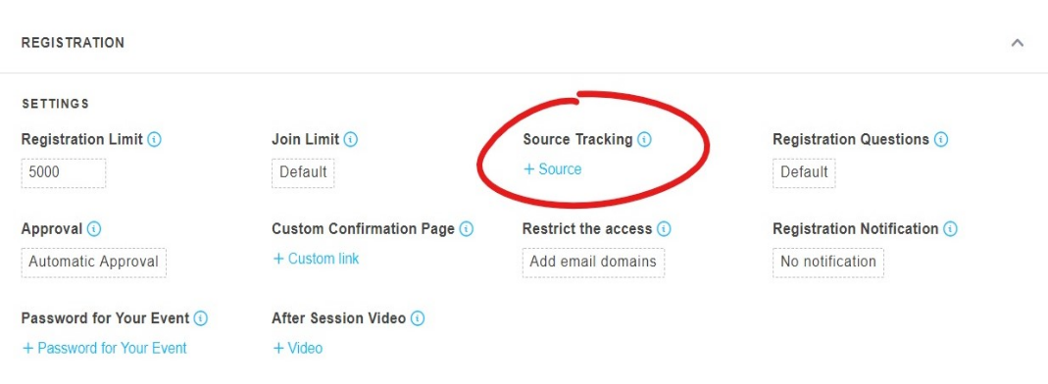

- Once we create you as a Source, GoToWebinar will generate you a specific link.
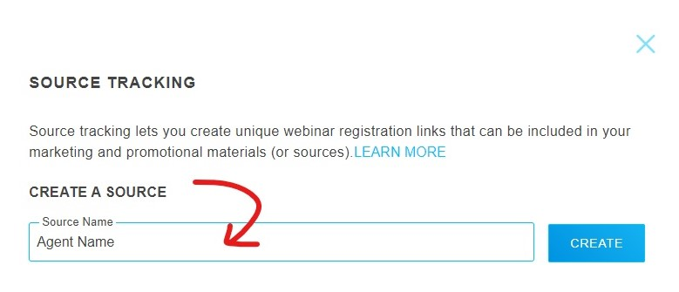

- We will send you the specific link that GoToWebinar generates for you (as seen below) so you can promote the webinar to your personal database.

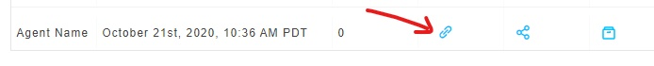

Here is your link: https://attendee.gotowebinar.com/register/3502601353157956366?source=Jason+Risley

- If someone registers for the webinar with your link, it will show on our registrants list with you as the source, and we will let you know.
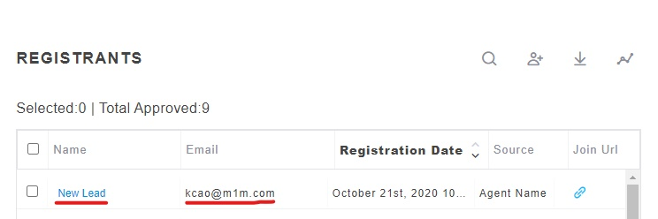
Receive free ongoing email marketing!
Sign up for a free account with Mailchimp.

If you have a Mailchimp account, we will share with you our templates for consumer direct marketing content:



